Biology I Standards-
What you need to know to pass
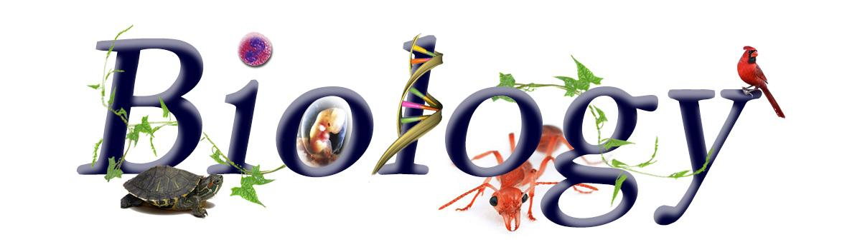

Embedded Inquiry-
You need to be able to ask scientific questions and conduct experiments.
- CLE 3210.Inq.1 Recognize that science is a progressive endeavor that reevaluates and extends what is already accepted.
- CLE 3210.Inq.2 Design and conduct scientific investigations to explore new phenomena, verify previous results, test how well a theory predicts, and compare opposing theories.
- CLE 3210.Inq.3 Use appropriate tools and technology to collect precise and accurate data.
- CLE 3210.Inq.4 Apply qualitative and quantitative measures to analyze data and draw conclusions that are free of bias.
- CLE 3210.Inq.5 Compare experimental evidence and conclusions with those drawn by others about the same testable question.
- CLE 3210.Inq.6 Communicate and defend scientific findings.

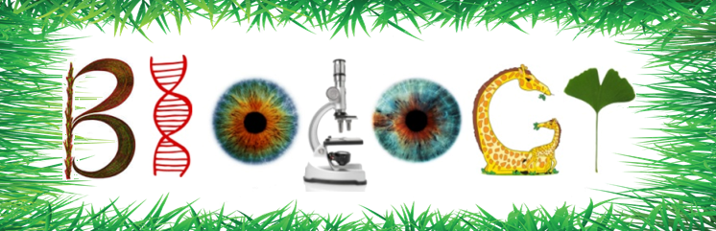
Embedded Technology and Engineering-
You need to understand how scientific and technological advances in engineering, math, medicine, and more help to benefit our society.
- CLE 3210.T/E.1 Explore the impact of technology on social, political, and economic systems.
- CLE 3210.T/E.2 Differentiate among elements of the engineering design cycle: design constraints, model building, testing, evaluating, modifying, and retesting.
- CLE 3210.T/E.3 Explain the relationship between the properties of a material and the use of the material in the application of a technology.
- CLE 3210.T/E.4 Describe the dynamic interplay among science, technology, and engineering within living, earth-space, and physical systems.


Embedded Mathematics-
You need to be able to recognize when math is necessary to do science, and you need to be competent in math to do science and communicate scientific findings.
- CLE 3210.Math.1 Understand the mathematical principles associated with the science of biology.
- CLE 3210.Math.2 Utilize appropriate mathematical equations and processes to understand biological concepts.

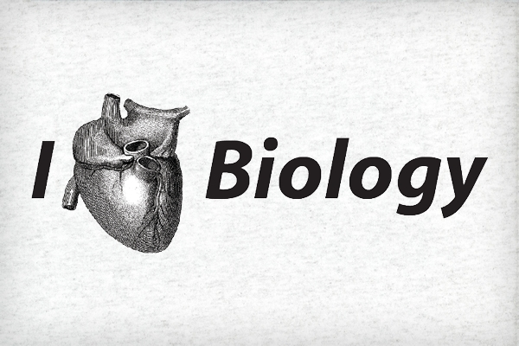

Cells-
All living things are made of cells and you need to be able to explain the different parts of cells and how they make up larger organizations of life.
- CLE 3210.1.1 Compare the structure and function of cellular organelles in both prokaryotic and eukaryotic cells.
- CLE 3210.1.2 Distinguish among the structure and function of the four major organic macromolecules found in living things.
- CLE 3210.1.3 Describe how enzymes regulate chemical reactions in the body.
- CLE 3210.1.4 Describe the processes of cell growth and reproduction.
- CLE 3210.1.5 Compare different models to explain the movement of materials into and out of
cells.
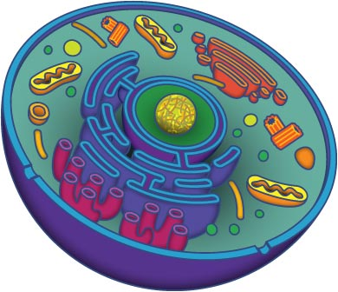

Interdependence-
You need to be able to explain how living things interact with their environment.
- CLE 3210.2.1 Investigate how the dynamic equilibrium of an ecological community is associated with interactions among its organisms.
- CLE 3210.2.2 Analyze and interpret population data, graphs, or diagrams.
- CLE 3210.2.3 Predict how global climate change, human activity, geologic events, and the introduction of non-native species impact an ecosystem.
- CLE 3210.2.4 Describe the sequence of events associated with biological succession.
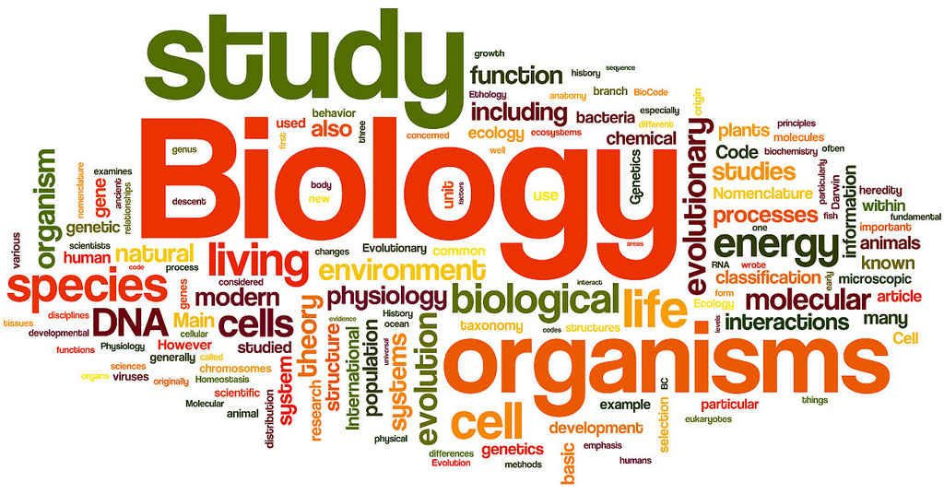

Flow of Matter and Energy-
You need to be able to explain how energy is exchanged and cycled between organisms and their environment.
- CLE 3210.3.1 Analyze energy flow through an ecosystem.
- CLE 3210.3.2 Distinguish between aerobic and anaerobic respiration.
- CLE 3210.3.3 Investigate the relationship between the processes of photosynthesis and cellular respiration.
- CLE 3210.3.4 Describe the events which occur during the major biogeochemical cycles.
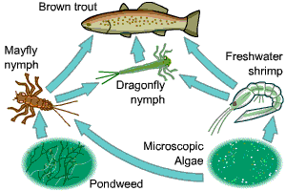

Heredity-
You need to be able to explain the structure of DNA, and how its function relates to the function of genes and chromosomes.
- CLE 3210.4.1 Investigate how genetic information is encoded in nucleic acids.
- CLE 3210.4.2 Describe the relationships among genes, chromosomes, proteins, and hereditary traits.
- CLE 3210.4.3 Predict the outcome of monohybrid and dihybrid crosses.
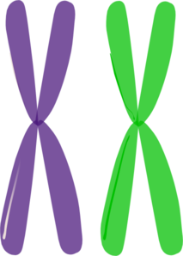
- CLE 3210.4.4 Compare different modes of inheritance: sex linkage, co-dominance, incomplete dominance, multiple alleles, and polygenic traits.
- CLE 3210.4.5 Recognize how meiosis and sexual reproduction contribute to genetic variation in a population.
- CLE 3210.4.6 Describe the connection between mutations and human genetic disorders.
- CLE 3210.4.7 Assess the scientific and ethical ramifications of emerging genetic technologies.

Biodiversity and change-
You need to be able how organisms can adapt and change in response to their changing environment.
- CLE 3210.5.1 Associate structural, functional, and behavioral adaptations with the ability of organisms to survive under various environmental conditions.
- CLE 3210.5.2 Analyze the relationship between form and function in living things.
- CLE 3210.5.3 Explain how genetic variation in a population and changing environmental conditions are associated with adaptation and the emergence of new species.
- CLE 3210.5.4 Summarize the supporting evidence for the theory of evolution.
- CLE 3210.5.5 Explain how evolution contributes to the amount of biodiversity.
- CLE 3210.5.6 Explore the evolutionary basis of modern classification systems.


